EXHIBITION CHECKLIST
10 September 2023
Scott Wolniak: Crosscurrents

1 | 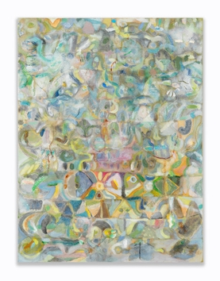 | Sunrise in the Folds, 2023  Acrylic, ink, graphite, soft and oil pastels, colored pencils on canvas  24 x 18 inches  61 x 45.7 cm  (SW15)
2 | 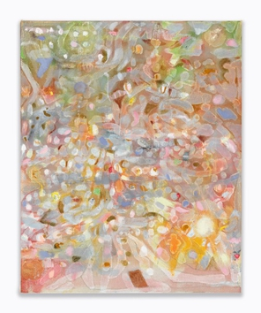 | Map Tree, 2023  Acrylic, oil, graphite, oil pastels, and soft pastels on canvas  21 x 17 inches  53.3 x 43.2 cm  (SW14)
3 | 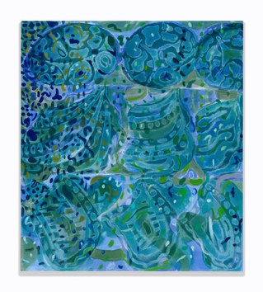 | Trickle-down Consciousness, 2023  Acrylic, oil, and graphite on canvas  27 x 24 inches  68.6 x 61 cm  (SW25)
4 | 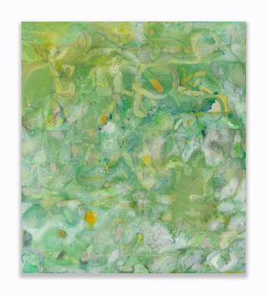 | Plant Writing, 2022  Acrylic, graphite, oil pastels, dry pigment and paper pulp on canvas  27 x 24 inches  68.6 x 61 cm  (SW13)
5 | 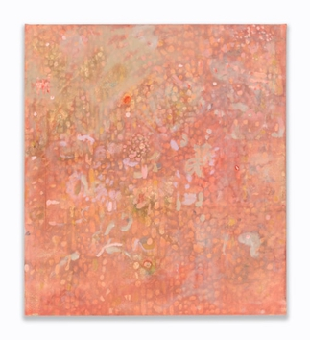 | Listening, 2023  Acrylic, oil, graphite, pumice medium on canvas  27 x 24 inches  68.6 x 61 cm  (SW10)
6 | 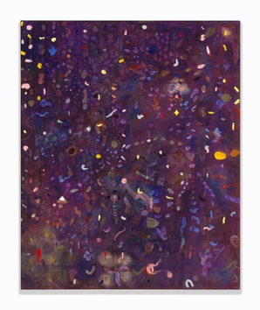 | Seeing with Eyes Closed, 2023  Acrylic, oil, graphite, saw dust and pumice medium on canvas  33 x 27 inches  83.8 x 68.6 cm  (SW28)
7 | 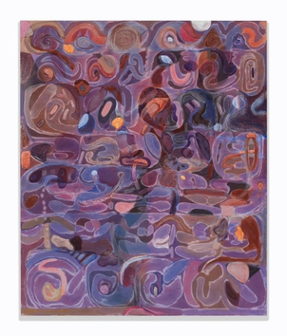 | Painting for Octopuses, 2023  Acrylic, graphite, pumice medium on canvas  36 x 30 inches  91.4 x 76.2 cm  (SW33) | SOLD
8 | 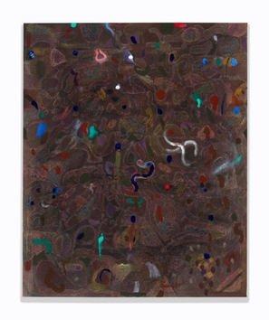 | When Do Roots Talk to Each Other? , 2023  Acrylic, oil, graphite and pumice medium on canvas  21 x 17 inches  53.3 x 43.2 cm  (SW27)
9 | 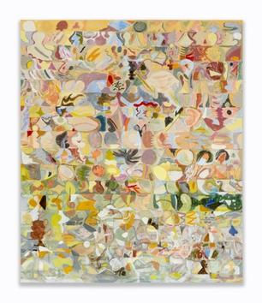 | Radish, Et Al, 2022  Acrylic, graphite, paper pulp and pumice medium on canvas  72 x 60 inches  182.9 x 152.4 cm  (SW11)
10 | 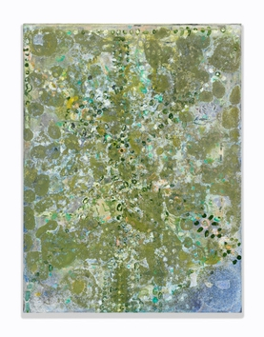 | Landscape Compression, 2023  Acrylic, gouache, oil, collage and pumice medium on canvas  16 x 12 inches  40.6 x 30.5 cm  (SW24)
11 | 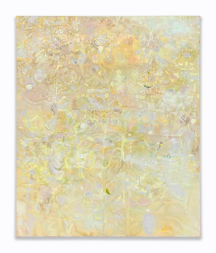 | To Become a Spiritual Seeker, 2021-2023  Acrylic, oil, oil pastels, colored pencils, graphite and pumice medium on canvas  33 x 27 inches  83.8 x 68.6 cm  (SW17)
12 | 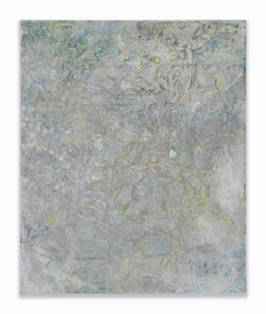 | Frost, 2022  Acrylic, graphite, colored pencils, and pumice medium on canvas  33 x 27 inches  83.8 x 68.6 cm  (SW18)
13 | 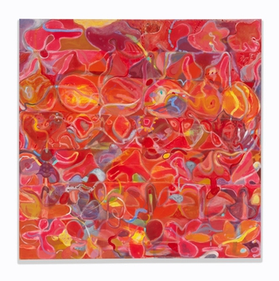 | Untitled (Red Painting), 2023  Acrylic, oil, graphite and pumice medium on canvas  50 x 50 inches  127 x 127 cm  (SW23)
14 | 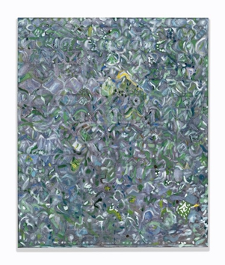 | Crosscurrents, 2023  Acrylic, oil, graphite, pumice medium on canvas  36 x 30 inches  91.4 x 76.2 cm  (SW31)
15 | 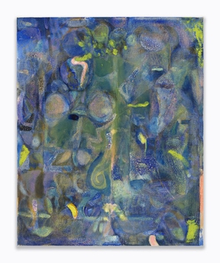 | Tendrils, 2022  Acrylic, oil, graphite, pumice medium on canvas  21 x 17 inches  53.3 x 43.2 cm  (SW20)
16 | 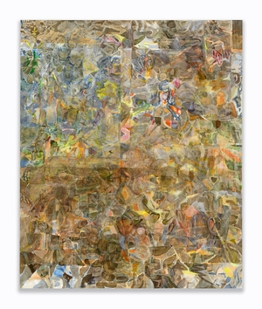 | Window and Bird, 2022  Acrylic and graphite on canvas  72 x 60 inches  182.9 x 152.4 cm  (SW16)
17 | 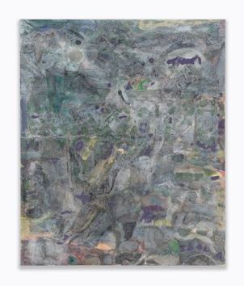 | The Cat, 2022  Acrylic, oil, graphite, saw dust and pumice medium on canvas  33 x 27 inches  83.8 x 68.6 cm  (SW19)  ADDITIONAL AVAILABLE WORKS  (Please inquire)
18 | 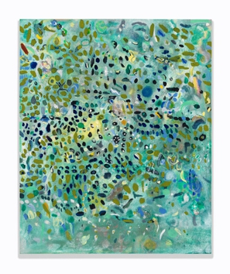 | Freedive, 2023  Acrylic, oil, graphite and pumice medium on canvas  21 x 17 inches  53.3 x 43.2 cm  (SW22)
19 | 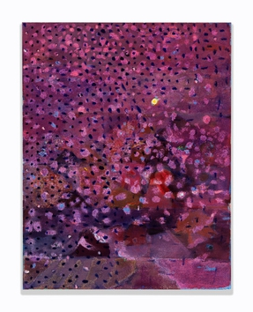 | Violet Snow, 2021-2023  Acrylic, oil, graphite, pumice medium on canvas  18 x 14 inches  45.7 x 35.6 cm  (SW26)
20 | 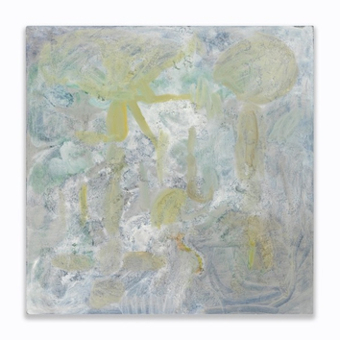 | Early Morning Dip, 2020-2023  Acrylic, oil, graphite, pumice medium and paper pulp on canvas  27 x 27 inches  68.6 x 68.6 cm  (SW21)
21 | 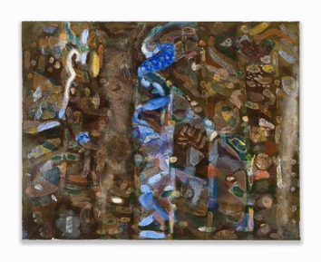 | River Sliver, 2022  Acrylic, oil, graphite and pumice medium on canvas  16 x 20 inches  40.6 x 50.8 cm  (SW30)
22 | 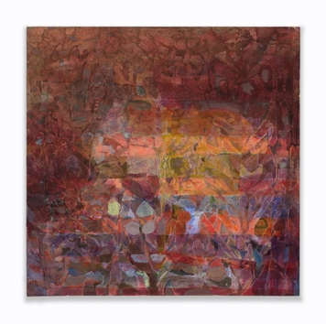 | Light Garden, 2020-2023  Acrylic, oil, graphite, and pumice medium on canvas  24 x 24 inches  61 x 61 cm  (SW12)
23 | 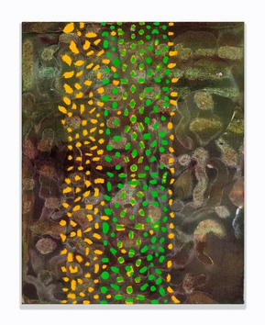 | Cascade, 2023  Acrylic, gouache, pumice medium on canvas  14 x 11 inches  35.6 x 27.9 cm  (SW32)

