Madeline Gallucci: sound of my father singing
November 4 – December 16, 2023
Exhibition Checklist

1 | 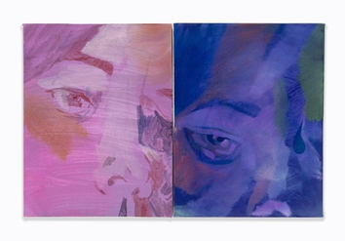 | Mirror (Faceshape), 2023  Acrylic and oil on canvas over panel, Acrylic and oil on canvas  18 x 12 x 1 inches (both combined)  45.7 x 30.5 x 2.5 cm
2 | 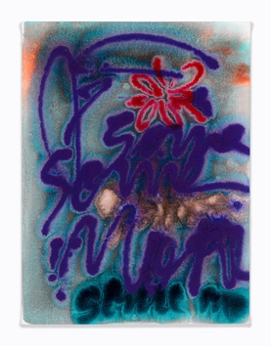 | Over me, 2023  Acrylic on canvas  18 x 24 x 1 inches  45.7 x 61 x 2.5 cm
3 | 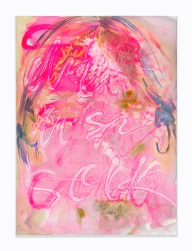 | Miss, 2023  Acrylic on canvas  30 x 40 x 1 1/2 inches  76.2 x 101.6 x 3.8 cm
4 | 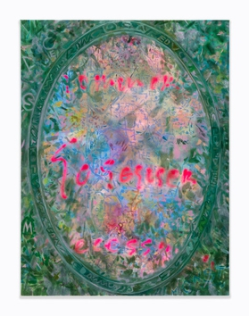 | Mirror (Lover’s Woods), 2022  Acrylic and oil on canvas  30 x 40 x 1 1/2 inches  76.2 x 101.6 x 3.8 cm
5 | 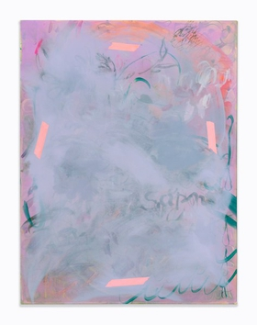 | Moonwatch, 2023  Acrylic and oil on canvas  30 x 40 x 1 1/2 inches  76.2 x 101.6 x 3.8 cm
6 | 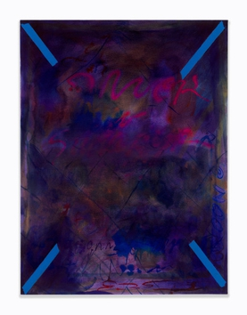 | Scam World, 2023  Acrylic and oil on canvas  30 x 40 x 1 1/2 inches  76.2 x 101.6 x 3.8 cm
7 | 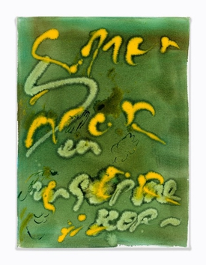 | Spammer, 2023  Acrylic on canvas  18 x 24 x 1 inches  45.7 x 61 x 2.5 cm
8 | 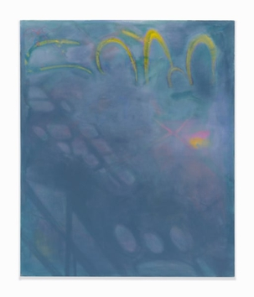 | Wait, 2023  Acrylic and oil on canvas  42 1/4 x 51 x 1 1/2 inches  107.3 x 129.5 x 3.8 cm
9 | 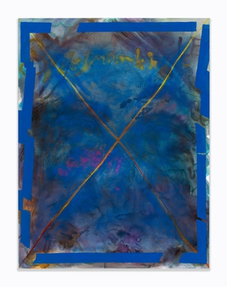 | Loss, 2023  Acrylic and oil on canvas  30 x 40 x 1 1/2 inches  76.2 x 101.6 x 3.8 cm
10 | 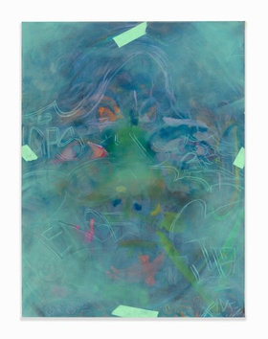 | Champagne on the rocks, 2023  Acrylic and oil on canvas  30 x 40 x 1 1/2 inches  76.2 x 101.6 x 3.8 cm
11 | 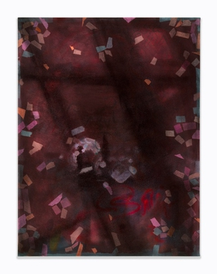 | Fallover, 2023  Acrylic and oil on canvas  30 x 40 x 1 1/2 inches  76.2 x 101.6 x 3.8 cm
12 | 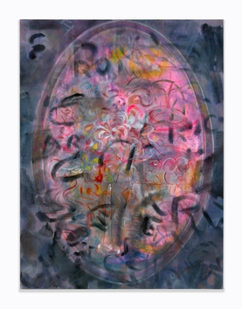 | Mirror (Rosters), 2022  Acrylic, ink, colored pencil and oil on canvas  30 x 40 x 1 1/2 inches  76.2 x 101.6 x 3.8 cm
13 | 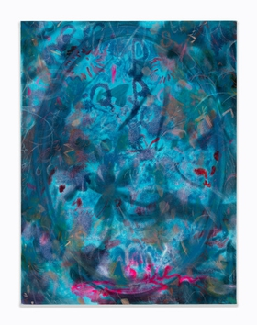 | Mirror (August), 2022  Acrylic, pastel, colored pencil and oil on canvas  30 x 40 x 1 1/2 inches  76.2 x 101.6 x 3.8 cm
14 | 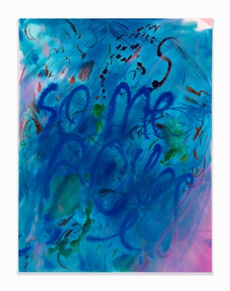 | Sooo Me, 2023  Acrylic and oil on canvas  30 x 40 x 1 1/2 inches  76.2 x 101.6 x 3.8 cm
15 | 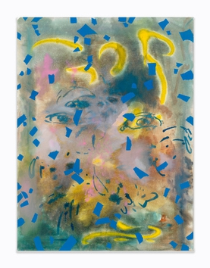 | Swim, 2022  Acrylic and oil on canvas  30 x 40 x 1 1/2 inches  76.2 x 101.6 x 3.8 cm

