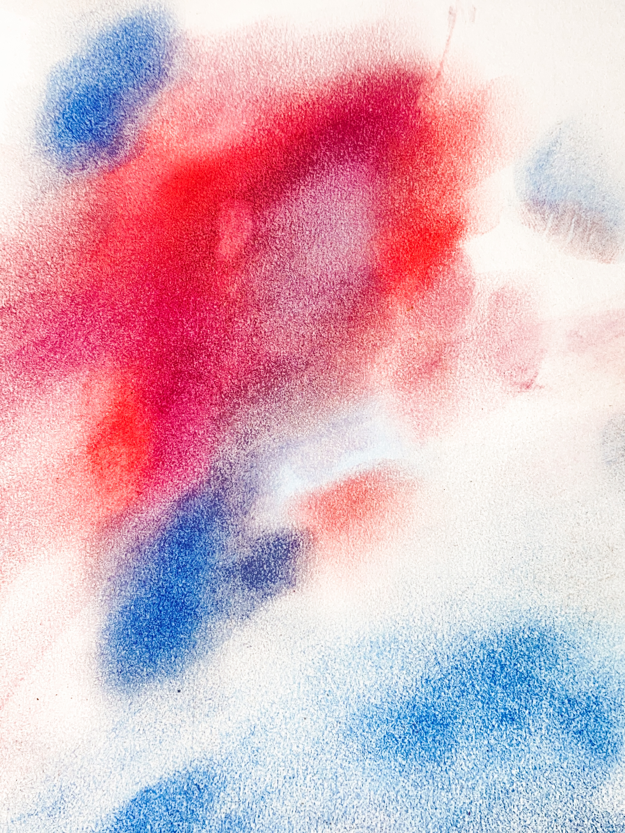

Hyun Jung Jun: by flame by fog
June 5 – July 17, 2021

Goldfinch is pleased to present “by flame by fog,” a solo exhibition by Hyun Jung Jun curated by Elizabeth Lalley in Gallery 2. The exhibition is on view from Saturday, June 5th through Saturday, July 17th.

Hyun Jung Jun’s work takes many forms, from temporary installations to candles to cakes, and the work often begins and ends as something changed or erased altogether. In the artist’s words, Jun’s creations “take up more time than they do space.” They are often made to disappear. Although Jun’s practice engages familiar, domestic processes (her kitchen serves as a studio space, where

she dips candles and experiments with cooking materials) her work seems to exist in a fantastical space where what is absent, shrouded, or entirely imagined is as real as anything else.
Jun’s candles, on view in the exhibition, are both playful and slightly monstrous; they range from vibrant winged creatures to more abstractly natural forms like knobby trees or stalactites, suggestive of the way dreams, memories, and experience can meld into something slightly misshapen but worthy of our attention. Sensual and temporary, Jun’s candles will melt; her cakes will be devoured; and the seedlings grown in eggshells inside the gallery will soon outgrow their containments. The painted wall on view in the exhibition, awash with a vivid landscape, will eventually vanish, like mist. In an associative way, Jun’s work gives us just enough, without crowding our senses, like a night walk illuminated by candlelight. Vibrant, introspective, and subtly unsetting—but beautifully so—the works in “by flame by fog” invite us to dream ourselves into other worlds, or more sensual versions of the ones we’ve come to know.

