Diana Gabriel: Permanence
Exhibition on view January 9 – February 12, 2022

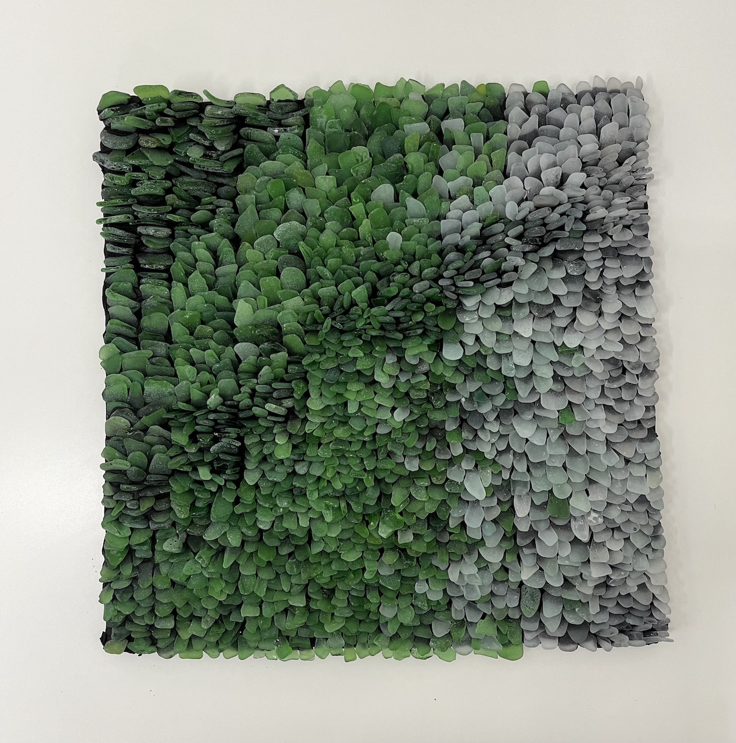
Quiet Passing, 2021, mixed media, 12 x 12 in

Goldfinch is pleased to present “Permanence,” our first solo exhibition with Diana Gabriel. Mounted in Gallery 2, Gabriel’s exhibition features works made over the past several years and during the Covid-19 Pandemic, which inspired the Colombian-American artist’s meditations on time as a concept that is both rigid and malleable. “Being in nature makes me feel small and insignificant,” Gabriel explains. “It helps me confront my mortality because of the permanence of the natural world.”
The majority of the works included in this show are made with rocks (including sea glass) of various colors, textures, and sizes, arranged and affixed to their substrates in linear compositions. “Rocks are timeless and permanent,” Gabriel notes, “but they exist in several forms across their existence. We are the same way in that we transition over time.” Gabriel found these rocks during her numerous beach walks over quarantine.

“Being on the beach, there are powerful forces, both visible and invisible. When the wind mixes with the lake, it can be extremely welcoming and dangerous at the same time. It is neither good nor bad. It is both peaceful and violent. We are all part of something greater that allows us to feel connected. It is related to the micro and the macro. When I inspect a rock, I can project myself onto it. The curiosity of holding something so small and amazing. The stories that these rocks could possibly tell. And meanwhile, these rocks are discovered in a vast space. The eye is pulled and pushed to try to take in all of these perspectives and scales at once. There is a rhythm in the picking. Bending down, standing up, the crunch of the rocks and the crashing of the waves. The repetition is soothing and ritualistic. It echoes my process of selecting, cleaning, sorting and cataloguing the pieces of rock and glass I bring from the beach.”

The use of line, pattern, and geometry in composition has always been central to Gabriel’s practice, which utilizes drawing, textiles, mixed media sculpture, ceramics, and large-scale installation in ways that recall childhood memories of family in Bogota. “Weaving, knitting, and macrame patterns were a constant of my childhood. The imagery in my artwork is inspired by memories of handmade patterns in baskets, plate settings, tapestries, tablecloths, and doilies under the flower vases from my grandmother’s home in Colombia. Borrowing aspects of these artisan traditions, I recreate such moments from my childhood, taking part in a conversation that emanates from countless generations of women artisans.”

Gabriel’s fascination with line and pattern also stems from an interest in processes of transition, in uncovering the logical steps that move a structure from one phase to another. “Transitions can be minuscule or substantial, but each is inherently crucial to the composition and value of the final whole. The work I make isn’t planned, shifting the emphasis from the final product to the process –the collecting and weaving of separate parts into something more than they were individually.”

Artist’ Bio

Born in Bogota, Colombia, Gabriel earned her BFA from Northern Illinois University in 2004, and her MFA from Illinois State University in 2007. She currently teaches at Harper College and College of Lake County in Illinois. She has exhibited in Chicago and nationally. Some venues include the Chicago Cultural Center, Ukrainian Institute of Modern Art, Chicago Artist Coalition, and Willis Tower. Her work has been published in New American Paintings, The Chicago Tribune, and Sixty Inches From Center. She has participated in the Connecting Communities Residency at the John Michael Kohler Arts Center in Sheboygan, WI, Interface Residency at Water Street Studios in Batavia, IL, and Ragdale Residency in Lake Forest, IL. Gabriel is also an Alma Award recipient from Latino Arts Inc. in WI and a 3Arts nominee.

